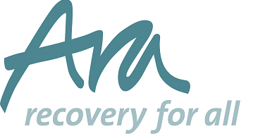

Ara BOARD MEMBER (VOLUNTARY)
Role Description

The 3 Pillars of being a Board member
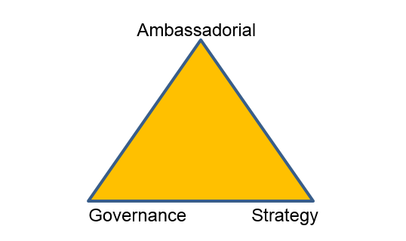

Collective governance and compliance responsibilities:

As a member of the Board of Trustees, a Board Member of Ara is responsible for:

- Ensuring the Ara pursues its objects as defined in its governing document
- Understanding and consistently undertaking your specific responsibilities written into the governing document
- Maintaining the democratic processes and accountability associated with Board membership
- Ensuring the Ara uses its resources exclusively in pursuance of its objects
- Full participation in Board activity to ensure:

  - That the Ara meets its legal obligations at all times
  - That the Ara’s financial obligations are met at all times and that all financial dealings are accounted for adequately
  - That the strategic direction of the Ara is set and monitored regularly
  - Have assurance that operational practice and performance is developed and monitored against targets, with individual performance reaching and being maintained at an excellent standard
  - Have assurance that regular reviews of Policy and Procedure, to meet legislative changes and take into account the requirements of other appropriate bodies, such as the Local Authority commissioning teams
  - Have assurance that all contracts in place are managed correctly to maximise performance and development opportunities, and that the Ara delivers services based on its contractual obligations
  - Employment practices are legal and that the Ara issues and abides by contracts of employment
  - Have assurance that the Ara regularly reviews the effectiveness of equal opportunities and anti-discriminatory practice
  - Have assurance that all required insurances are in place and paid for as necessary
  - That all premises are legally managed, safe and secure for use by staff, service users and visitors
  - That the good name and values of the Ara are safeguarded

The following points summarise your key duties and responsibilities as a Board member. You must uphold the 7 principles of public life:-

Selflessness; integrity; objectivity; accountability; openness; honesty; leadership.

- You must uphold the values and objectives of the Ara and if these are not clear you must seek clarification from the Chair and/or the CEO.
- You must give adequate time and energy to the duties of being a Board member which includes not only preparing for, attending and participating in formal meetings, but also being present at occasional informal gatherings and reunions of staff and clients when possible.
- You must perform your duties with integrity, avoiding conflicts of interest whenever possible but otherwise, declaring them at every opportunity and, if requested, declining involvement in discussions when a conflict arise or withdrawing from the meeting for that agenda item.
- You must not act on your own on behalf of the Board, or on the business of the Ara, without the proper authority of the Board. In particular you must not give instructions to or make requests of members of staff but you should always approach staff initially through the Chair who will discuss the matter with the CEO.
- In all dealings with staff you must act formally, courteously and respectfully and should avoid discussing your own or a staff member’s personal matters.
- You are expected to attend most Board meetings and must send your apologies to the Chair or CEO giving seven days’ notice if possible. If you fail to attend three consecutive meetings, you will be deemed to have given up your Board membership unless legitimate reasons for absence have been given to the Board and formal leave of absence granted, which will usually be for a limited period only.
- You must provide any relevant information reasonably required by the Ara for the conduct of good governance
- If you have any doubt or concern about any matter relating to the ARA’s activities, however slight, you must raise it with the Chair or the Vice Chair in the first instance.

In the course of participating in the scrutiny and leadership of the Ara’s operations, it is expected that you will openly raise concerns or queries to prevent impropriety and promote best practice, actively contributing to debate and discussion. The principal course of action about concerns in Board or Committee papers will be to raise them with relevant Director, CEO or committee in the first instance as we operate a no surprises ethos at meetings.

It is also expected that all Board Members will be committed to the purpose, objects, values and ethos of the Ara.

